**Rotorua One Day School: Principal’s Permission**

The One Day School programme is designed to provide additional differentiated challenge and support for those gifted learners whose different learning needs it can be difficult to meet within the regular classroom.

We work cooperatively with the school and see our work with the child as supporting the work of the classroom teacher. We maintain a regular liaison with the classroom teacher through news sheets and term reports and are open to further contact at any time.

The programme is funded by a local charitable trust. There is no cost to your school. The only cost to whanau is a $50 contribution once each term towards resources. This can be met if there is hardship.

We have received an application for the following child to be enrolled in this programme:

**Child’s name:**  ________________________________________________________________

**Requirements:**

* No child attending a regular school can be accepted into this programme without your signed permission.
* Each child who receives your permission to apply for the programme will undergo a comprehensive qualitative and quantitative assessment process. This will take approximately two hours and will be held at the LaunchPad building on the corner of Hinemoa and Hinemaru Streets, on a date to be advised.
* Each accepted child will then attend the programme for one full day every week of each term.

**What happens now**

{1} This application needs to be accompanied by:

* The completed teacher’s questionnaire
* The completed parent questionnaire
* An example of the child’s original creative work in any form, completed at either school or home, and dated with at least the year of completion
* The child’s completed interest form
* Your signed permission slip (see below).

{2} Please ask your school office to collate these various items into one package or folder.

[3} Please then ask your school office to collate this package together with any other applications and either to scan them and email to [giftedreach@aotearoagifted.nz](mailto:giftedreach@aotearoagifted.nz) OR to **courier** them to:

**Dr R Cathcart, 18/40 Owhatiura Drive, Lynmore, Rotorua 3010.**

Any queries? Email [giftedreach@aotearoagifted.nz](mailto:giftedreach@aotearoagifted.nz)

**…………………………………………………………………………………………………………………….**

**Your permission:**

I, _______________________________________________________________________________

Principal of _________________________________________________________________ School,

hereby give permission for _______________________________________________________

to attend the **One Day School Assessment Day**, and, if accepted, to be enrolled in the One Day School programme.

Signed: _________________________________________________________ Date: / /

Rotorua One Day School: **TEACHER QUESTIONNAIRE**

Your name & role (eg class teacher): ____________________________________________________________________

Your email address: ____________________________________________________________________

Child’s name: _________________________________________________________

School: ______________________________________________________________

*This questionnaire has been specially developed to reflect a bi-cultural and holistic definition of giftedness appropriate for Aotearoa New Zealand. All terms can apply to any child from any cultural background. Our grateful thanks to Claire and Pita Mahaaki for their guidance and support with this.*

1. **Please state here your rationale for recommending this child for the One Day School:**
2. **Please list here any area of learning or performance where the child has demonstrated exceptional ability and understanding:**
3. **Please place a tick beside any quality or behaviour which is strongly characteristic of this child** *(Please see next page for any terms which are not familiar to you. Please also feel free on p. 2 to add any additional comments or information it would be helpful for us to know).*

[ ] Manaakitanga

[ ] Whanaungatanga

[ ] Wairuatanga

[ ] Kaitiakitanga

[ ] Rangitiratanga

[ ] Matauranga

[ ] Tikanga

[ ] Intellectual ability, intrinsic motivation to learn, thinks critically, learns quickly, can transfer

knowledge to new contexts, can analyse, problem find and problem solve.

[ ] Strong curiosity, a keen observer, persistent in questions, sustains interests, long attention span (if interested), demonstrates initiative.

[ ] Creative thinker, produces innovative solutions, work often highly imaginative.

[ ] Intensity of feeling and response, passionate, sensitive to others, concerned with issues of justice, compassionate, willing to question authority.

[ ] Active and often witty sense of humour, sees irony in situations, appreciative of the absurd.

] ] Often prefers older or adult company, may seem introverted, may display many of the above characteristics only in trusted or safe company.

*But also gifted learners who have not previously been identified or have had negative experiences at school or amongst peers may show characteristics such as these:*

[ ] A nuisance in class, over-active, a show-off, the class clown.

[ ] A loner; does not fit in with other students.

[ ] Uncooperative, resentful of authority.

[ ] Anxious, seems excessively worried about her/his work, never a risk-taker.

[ ] Work is generally fairly average, doesn’t seem to try particularly hard, but every now and then produces flashes of brilliance that really surprise you.

[ ] Written work is of average to poor quality, but orally is articulate, shows considerable imagination not expressed in written work.

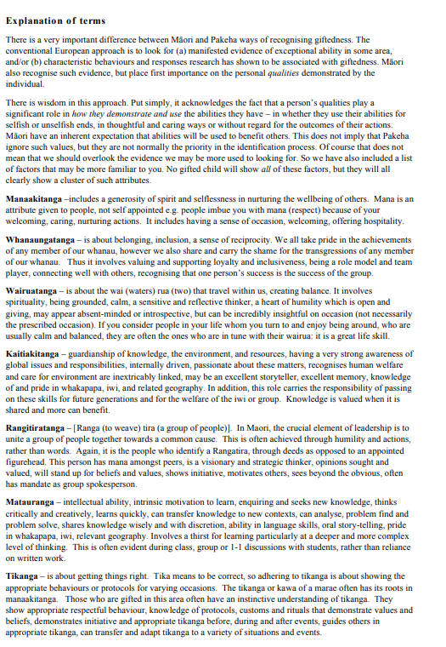

*And additional comments you would like to add?*

______________________________________________________________________

______________________________________________________________________

______________________________________________________________________

______________________________________________________________________

**Whanau/Parent Questionnaire: the One Day School programme**

One Day School has been designed for children who may not find the normal school programme fully meets their learning needs. Our task at this stage, with your help, is to make sure the One Day School will fill that gap and be a satisfying experience for your child. You have a very important part to play in this process!

**Please tick the boxes below to show you have included the following items:**

[ ] Your completed whanau/parent questionnaire and permissions form

[ ] Your completed health and contact details form

[ ] Your child’s completed “Getting to know you” form

[ ] An example of your child’s original creative work in any field, from home or school

* This could be anything your child has designed, invented, built, made or created – eg a painting, a poem, a construction of some kind, a sewn or knitted item, a video made by or about the child, a pottery creation, and so on. Items like these can give us a very valuable insight into a child’s thinking and understanding that we cannot get in any other way.
* Please ensure you attach a note on how old your child was when this item was created. Thank you!

**[Item1] WHANAU/PARENT NOMINATION FORM**

Child’s name_______________________________________________________________

What are the characteristics which have made you think your child might be gifted or exceptionally able? Please tick any of the following which apply. Feel free to add others or to make additional comments that would help us to understand your child.

**NB:** Don’t worry - no child is expected to show all these characteristics!

***At pre-school level your child:***

[ ] had little need for sleep

[ ] demanded attention constantly

[ ] spoke fluently and was using some complex words or phrases before age two

[ ] was extremely alert and “noticing”, very observant of detail

[ ] was intensely curious, always asking questions

[ ] was very independent, loved doing things for her/himself (eg dressing, feeding)

[ ] learned to read *before* going to school

[ ] was quickly bored with simple or repetitive toys

[ ] could concentrate for long periods when her/his interest was caught (30 minutes or more)

[ ] was very sensitive, distressed by hurt experienced by other people or animals

[ ] seemed to prefer the company of older children or adults

[ ] was withdrawn, did not seem to “fit in” with other children

[ ] displayed an exceptional memory, eg of places visited, events

[ ] displayed a highly developed sense of humour.

***Since reaching school age, she/he:***

[ ] has developed an intense continuing interest in _________________________________________

[ ] asks reasons why – questions everything

[ ] is always busy eg “experimenting”, designing, making things, creating projects, drawing, etc

[ ] is a day-dreamer

[ ] is persistent, determined, sticks to task

[ ] is often too absorbed in own activities to be aware of other things

[ ] shows strong perfectionist tendencies – things must be exactly right

[ ] is self-sufficient; likes to be on her/his own for extended periods of time

[ ] worries about and often discusses social and moral issues

[ ] reads voraciously

[ ] is impatient with others who do not think or work as quickly as she/her does

[ ] is rather lonely, seems to find it difficult to make friends

[ ] finds it easy to make friends; seems confident and popular.

[ ] is enjoying school, seems to feel interested and sufficiently challenged

[ ] often says school is boring or too easy

[ ] is critical of school and/or teachers

[ ] likes to work independently of others; may express dislike of group work at school

* *Is there anything else you would like to add to this list?*

______________________________________________________________________

______________________________________________________________________

______________________________________________________________________

______________________________________________________________________

______________________________________________________________________

______________________________________________________________________

______________________________________________________________________

______________________________________________________________________

*Please continue to the Photo and Internet Agreement for you and your child – thank you.*

**[2] Permissions:**

**Photos:** From time to time we take photos of the One Day School class in action, to record our activities for our files and occasionally for Facebook or PR. Do we have your permission to include your child in such photos?

[ ] Yes [ ] No

Signed: …………………………………………………………………………………………………………………………………

**Student Internet Use Agreement:**

I …………………………………………. (student’s name) understand and agree to the following rules and guidelines for the use of the internet while at One Day School:

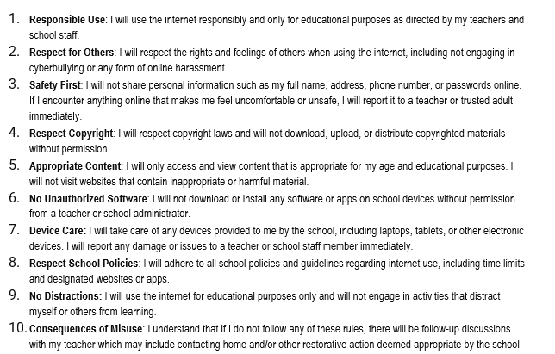

I have read and understand the above rules for internet use at One Day School, and I agree to abide by them at all times.

Student Signature: ________________________________________________________________________________

Date: ___________________________________________________________________________________________

Parent/Guardian Consent

I, [Parent/Guardian's Name]:________________________________________________________________________

have read and discussed the above rules for internet use with my child. I understand that it is important for my child to use the internet responsibly and for educational purposes while at Rotorua One Day School. I consent to my child's agreement to abide by these rules.

Parent/Guardian Signature: __________________________________________ Date: ___________________________

**[3] Rotorua One Day School: Contact & Health Information**

Child’s name: _______________________________________________________

Date of birth: ________________________________________________________

Likes to be called: _____________________________ Gender: _______________

Iwi affiliation: ________________________________________________________

Other ethnicity: ______________________________________________________

Number of older siblings: _______________ Younger siblings: _________________

Lives with (mother/father/both parents/whanau/grandparents/other) – please circle

Name of main contact person at home:____________________________________

Home street address: __________________________________________________

Home/work/mobile phones: _____________________________________________

Email: ______________________________________________________________

**\*Emergency contact:**

Name: _______________________________ Relationship: ______________________

Phones (Home/work/mobiles): ______________________________________________

**If parents are separated:**

1. Please advise here if contact is not permitted: Yes No
2. Otherwise, please provide the other parent’s name: _______________________

Contact address (for reports etc): ______________________________________

and Email: _______________________________________________________

**Health:** Does your child have any medical condition or allergy that we need to know about? Please list here: _________________________________________________________

______________________________________________________________________

Will you be supplying any medication for us to hold here for this condition? Yes No

Please give details: _______________________________________________________

______________________________________________________________________

Your medical practice/centre: _______________________________________________

|  |
| --- |
| **Note: Don’t forget to tick ALL FOUR boxes before you hand this in! (This questionnaire, the permissions page, the Health & Contact Form, your child’s creative work, and lastly, your child’s “Getting to Know Form”)** |

**Rotorua One Day School**

**Note to parents:**  Your child should complete this themselves, in their own words. Please don’t worry if your child’s writing is untidy or badly spelt – we are used to interpreting children’s work! Unless your child suffers from an issue such as dyslexia, it is important for this to be the child’s own work.

Getting to know you!

We run a programme called One Day School. It means that you go to your ordinary school for four days a week but spend the fifth day in this programme to do some different kinds of learning. We would like to know if this programme would suit you. Can you help us to find that out? Your answers to the questions below will help us decide!

[1] Your name: _____________________________________________________________

[2] What kinds of things make you curious so that you want to find out more? For example, how computers work, making pottery, saving our native forests. What’s on your list?

_______________________________________________________________________

_______________________________________________________________________

[3] What kind of learning do you like to do? Tick all the items in this list that are true for you:

{ } Work where I can use my imagination

{ } Work where I have some choices in what I do

{ } Active “doing” work, like projects or experiments

{ } Work where I can ask all the questions I have thought of

{ } Work which gives me some proper challenge for my mind

{ } Working with kids like me who think like I do

[4] When you have free time, at home or at school, what do you like to do? For example, playing sport, games like chess, reading, making models, making huts, gaming, cooking. What do you like to do?

_______________________________________________________________________

_______________________________________________________________________

_______________________________________________________________________

[5] Finally, you might not have thought about this yet, but if you have, what is your dream for your future?

_______________________________________________________________________

_______________________________________________________________________

_______________________________________________________________________